
SIMATS ENGINEERING
Saveetha Institute of Medical and Technical Sciences
Chennai-602105

AQUAGUARD 360: INTELLIGENT WATER QUALITY MONITORING AND PREDICTIVE CONTAMINATION ALERT SYSTEM

S ROOPAN RAJ(192525474)
B.Tech AI&ML

DECLARATION

I hereby declare that the project entitled "AquaGuard 360: Intelligent Water Quality Monitoring and Predictive Contamination Alert System" submitted in partial fulfillment of the requirements for the award of the degree of Bachelor of Engineering in Artificial Intelligence and Machine Learning is a record of original work carried out by me under the guidance of Dr. ANITADAVAMANI, Department of Artificial Intelligence and Machine Learning, Saveetha Engineering College.
I further declare that this project has not previously formed the basis for the award of any degree, diploma, associate ship, fellowship, or any other similar title in any University or Institution.

Date: /08/2026 Signature of the Student
Place: Chennai S. ROOPAN RAJ

ACKNOWLEDGEMENT
I express my sincere gratitude to Saveetha Engineering College, Chennai, for providing an excellent academic environment and the necessary facilities to carry out this project successfully.
I extend my heartfelt thanks to the Principal of Saveetha Engineering College for providing continuous encouragement, motivation, and institutional support throughout the completion of this project.
I express my sincere gratitude to the Head of the Department of Artificial Intelligence and Machine Learning for providing valuable guidance, encouragement, and the necessary infrastructure required for the successful completion of this work.
I am deeply indebted to my project guide, Dr. ANITADAVAMANI, for their constant encouragement, technical expertise, valuable suggestions, and continuous supervision throughout every stage of this project. Their guidance played a vital role in shaping this work into its present form.
I also thank all the faculty members of the Department of Artificial Intelligence and Machine Learning for sharing their knowledge and extending their support whenever required.
Finally, I express my heartfelt gratitude to my parents, family members, friends, and classmates for their unwavering encouragement, motivation, and moral support throughout the development of this project.

1. INTRODUCTION
Water is an essential natural resource that supports human life, agriculture, industries, and environmental sustainability. However, increasing industrial pollution, agricultural runoff, and microbial contamination have made continuous water quality monitoring a major challenge. Traditional monitoring methods depend on manual sample collection and laboratory analysis, which often delay contamination detection and corrective action.
AquaGuard 360 is an intelligent water quality monitoring and predictive contamination alert system that combines IoT sensors, Artificial Intelligence (AI), Machine Learning (ML), Cloud Computing, Git, and Docker to continuously monitor water quality. Sensors collect parameters such as pH, turbidity, temperature, dissolved oxygen, and conductivity, while AI algorithms analyze the collected data to predict contamination risks and generate real-time alerts.
The project also follows modern software engineering practices by using Git for version control and Docker for containerized deployment, making the application easier to develop, maintain, and deploy consistently across different environments.

2. PROBLEM ANALYSIS
Conventional water quality monitoring systems rely on periodic laboratory testing, making early contamination detection difficult. Since water quality can change rapidly, delayed analysis may result in contaminated water reaching consumers before corrective actions are taken.
AquaGuard 360 addresses this problem by continuously collecting sensor data, storing it in a centralized database, analyzing it using AI models, and generating instant alerts whenever abnormal conditions are detected. The system also provides an interactive dashboard that allows water authorities to monitor multiple water sources in real time.

3. PROJECT OBJECTIVES
The main objectives of AquaGuard 360 are:
- Develop an IoT-enabled water quality monitoring system.
- Monitor pH, turbidity, temperature, dissolved oxygen, and conductivity continuously.
- Predict contamination using Artificial Intelligence.
- Generate real-time alerts during abnormal conditions.
- Store historical sensor data in cloud storage.
- Provide dashboards and automated reports.
- Support collaborative development using Git.
- Deploy the application consistently using Docker containers.

4. FUNCTIONAL REQUIREMENTS
The AquaGuard 360 system performs several important functions.
- User authentication and role management.
- Continuous collection of sensor data.
- Storage of sensor readings in a centralized database.
- AI-based contamination prediction.
- Real-time alert generation.
- Dashboard visualization.
- Historical report generation.
Module | Function
Authentication | Secure User Login
Sensor Module | Real-Time Monitoring
AI Engine | Contamination Prediction
Dashboard | Live Data Visualization
Alerts | Emergency Notification
Reports | Historical Analysis

5. PROJECT STRUCTURE DESIGN
A well-organized repository improves software maintenance and collaborative development. The AquaGuard 360 project separates the frontend, backend, AI module, Docker configuration, and documentation into independent folders. This modular organization reduces code duplication, improves readability, and allows developers to work on different components without affecting the complete project.
The repository also contains configuration files such as README.md, requirements.txt, and .gitignore, which simplify dependency management, documentation, and version control.
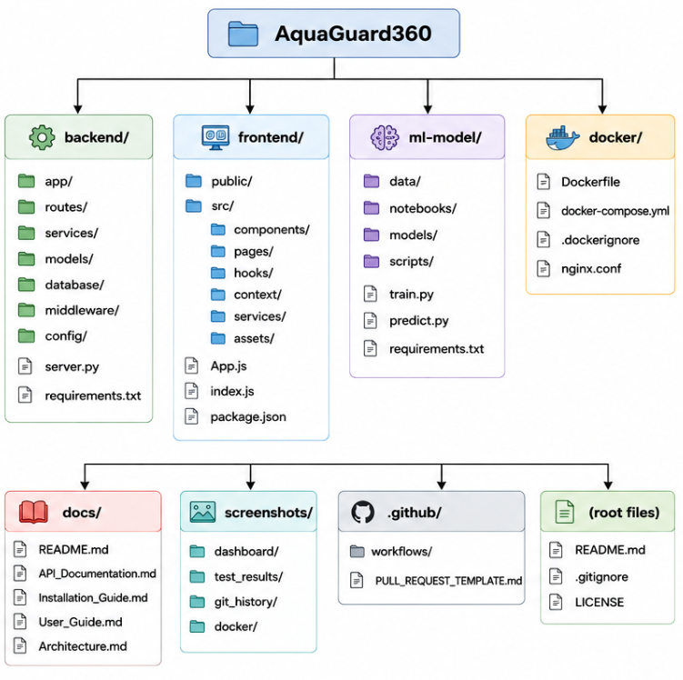

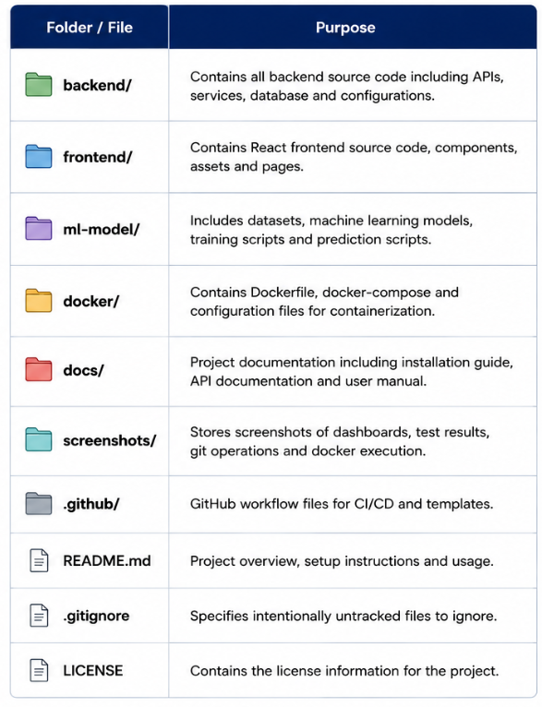

6. GIT REPOSITORY INITIALIZATION
The AquaGuard 360 project begins by creating a Git repository inside the project folder. Repository initialization creates a hidden .git directory that stores commit history, branch information, repository configuration, and version tracking details.
After initializing the repository, project files are added to the staging area and committed with meaningful commit messages. The repository is then connected to GitHub to enable collaborative development and backup of source code.
Common Git Commands
git init

git add .

git commit -m "Initial project setup"

git remote add origin https://github.com/username/AquaGuard360.git

git push -u origin main
These commands create the repository, track project files, create the first commit, and upload the project to GitHub.

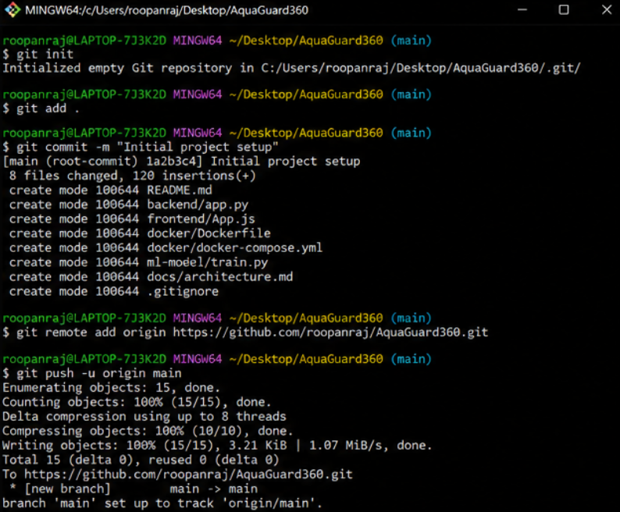

7. GIT BRANCHING STRATEGY
To support collaborative software development, AquaGuard 360 follows a structured branching model. The Main branch stores the stable production version of the application, while the Develop branch is used to integrate completed features before release.
Individual features such as AI prediction, dashboard development, and Docker deployment are implemented in separate Feature branches. Once testing is completed, these branches are merged into the Develop branch. Release branches are used before production deployment, while Hotfix branches correct critical issues found after deployment.
Branch | Purpose
Main | Stable Production Version
Develop | Integration of Features
Feature | New Feature Development
Release | Final Testing
Hotfix | Emergency Bug Fixes

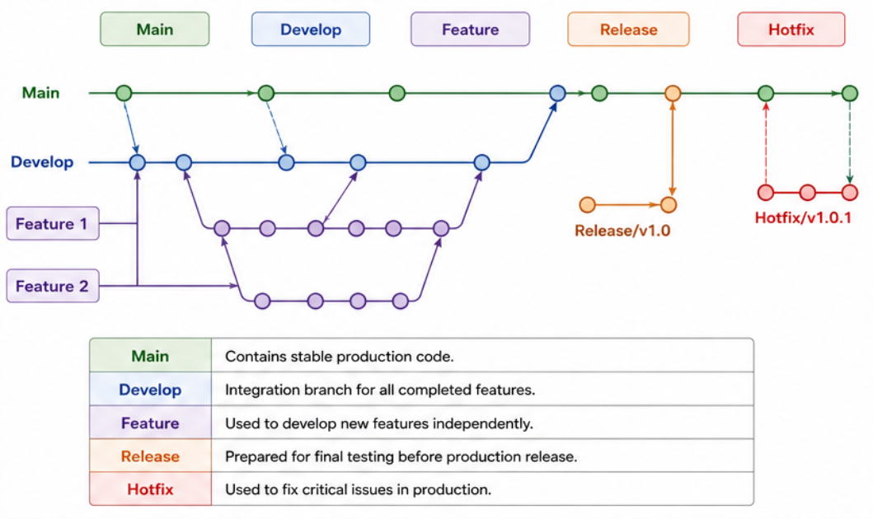

8. VERSION CONTROL WORKFLOW
Git records every modification performed during software development. Whenever a developer changes the source code, Git first identifies modified files using git status. The required files are then added to the staging area using git add and permanently saved using git commit.
After successful testing, commits are pushed to the remote GitHub repository using git push. Developers synchronize the latest project updates using git pull, ensuring that everyone works with the latest version of the application.
The simplified development workflow is:
Modify Code
↓
git status
↓
git add
↓
git commit
↓
git push
↓
GitHub Repository
This workflow provides complete traceability of software changes and supports collaborative development.

9. COMMIT HISTORY ANALYSIS
Every important modification made during the development of AquaGuard 360 is recorded as a separate commit. Meaningful commit messages help developers understand project progress and simplify debugging.
Example commit history:
Commit | Description
Initial Project Setup | Repository Created
Backend APIs Added | REST Services Implemented
AI Prediction Module | Machine Learning Added
Dashboard Developed | User Interface Completed
Docker Integration | Containerization Added
Final Release | Stable Version
A clean commit history improves project maintenance by allowing developers to identify changes quickly and restore previous versions whenever required.

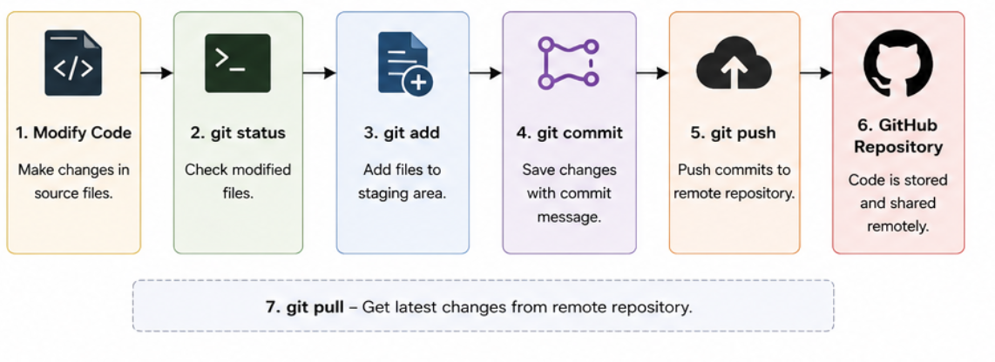
10. DOCKER ENVIRONMENT DESIGN
The AquaGuard 360 application consists of multiple components including the frontend dashboard, backend API, AI prediction module, and database. Docker containerizes each component separately, allowing them to run independently while communicating through a common Docker network.
This modular deployment approach improves scalability, maintenance, and fault isolation. Each container contains all the libraries and dependencies required for its respective service, eliminating compatibility issues between different systems.

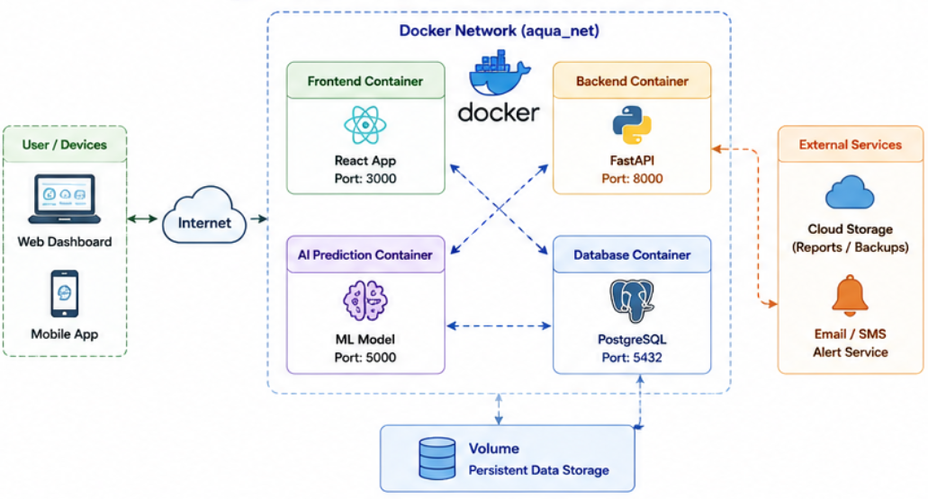

11. DOCKERFILE AND DOCKER COMPOSE
A Dockerfile defines the steps required to build a Docker image for the application. It specifies the base image, working directory, required dependencies, application files, and the command used to start the application.
Example Dockerfile:
FROM python:3.11

WORKDIR /app

COPY . .

RUN pip install -r requirements.txt

CMD ["python","app.py"]
Docker Compose simplifies deployment by defining all project services inside a single configuration file. Using a single command, all containers including the frontend, backend, AI module, and database can be started simultaneously.

12. CONTAINER DEPLOYMENT AND TESTING
After creating the Docker images, the application is deployed using Docker Compose.
Common deployment commands include:
docker compose build

docker compose up

docker ps

docker compose down
Testing confirmed that all containers started successfully and communicated properly. The frontend dashboard displayed sensor readings, backend APIs processed requests correctly, and the AI prediction module generated contamination alerts using simulated sensor data.

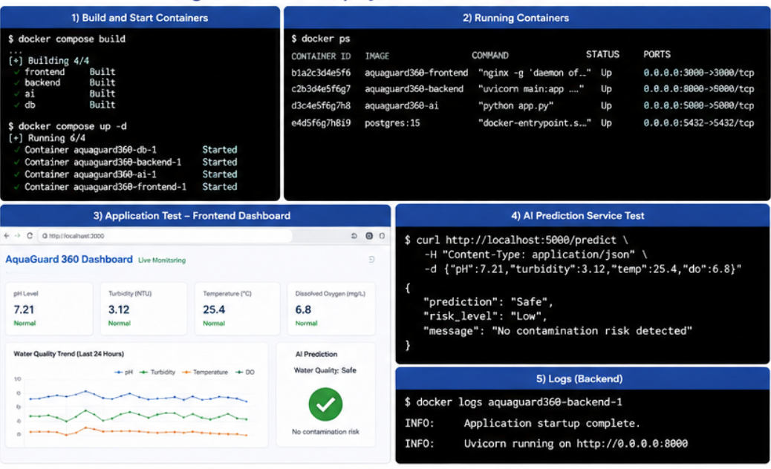

13. BENEFITS, CHALLENGES AND FUTURE ENHANCEMENTS
Using Git and Docker provides several advantages during the development of AquaGuard 360.
Benefits
- Improved collaboration using Git.
- Complete version history of the project.
- Consistent deployment using Docker.
- Easy portability across different operating systems.
- Simplified software maintenance.
- Faster application deployment.
Challenges
- Merge conflicts during collaborative development.
- Docker networking configuration.
- Managing environment variables.
- Learning Git branching strategies.
Future Enhancements
- Integrate GitHub Actions for CI/CD.
- Deploy using Kubernetes for scalability.
- Host the application on cloud platforms such as AWS or Azure.
- Implement automated security scanning and monitoring.

14. CONCLUSION
The AquaGuard 360 project demonstrates how Git and Docker improve modern software development practices. Git provides efficient version control by maintaining project history, enabling collaboration, and supporting structured development workflows. Docker complements Git by containerizing the application and ensuring consistent execution across different environments.
Together, these technologies improve software portability, maintainability, scalability, and deployment efficiency. AquaGuard 360 successfully combines intelligent water quality monitoring with modern software engineering practices, providing a reliable foundation for future development and real-world deployment.

REFERENCES
- Git Documentation
- Docker Documentation
- Docker Compose Documentation
- Atlassian Git Tutorials
- Ian Sommerville – Software Engineering
- Roger S. Pressman – Software Engineering: A Practitioner's Approach
- AquaGuard 360 Project Documentation

